Assignment – 1

Q1. Write HTML code to do the following tasks.
o Change the title of the page to "Internet and Web Technology Lab"
o Display the heading "Web Technology Basics" using an <h1> tag.
o Add at least two paragraphs describing the importance of web development.
o Create a hyperlink with a display text "Read More" to go to https://en.wikipedia.org/wiki/Internet.
o Create another link to open Google in a new tab.
o Insert an image of your choice into the webpage and control its height and width using attributes.
Code:
<!DOCTYPE html>
<html>
<head>
<title>Internet and Web Technology Lab</title>
</head>
<body>
<h1>Web Technology Basics</h1>
<p>
Web development is important because it forms the backbone of how individuals, businesses, and organizations present
themselves and interact online. A well-developed website helps create a strong digital presence, making information,
products, and services easily accessible to users across the world. It enhances communication, improves user experience,
and builds credibility and trust. In today’s digital age, websites also act as powerful marketing tools, helping
businesses reach a wider audience, increase visibility, and stay competitive in a fast-growing online marketplace.
</p>
<p>
In addition, web development supports innovation and efficiency by enabling the creation of dynamic, interactive, and
scalable applications. From e-commerce platforms and educational portals to social media and cloud-based services,
modern web applications simplify daily tasks and improve productivity. Web development also allows integration with
databases, APIs, and emerging technologies, making systems smarter and more responsive. Overall, it plays a crucial
role in digital transformation, driving economic growth and shaping how people connect and share information globally.
</p>
<a href="https://en.wikipedia.org/wiki/Internet" target="_blank">Read More</a>
<br>
<a href="https://www.google.com/" target="_blank">Google</a>
<br>
<img src="C:\Users\DELL\Desktop\College\24BCSH03\4th Sem\IWT LAB\Internet.avif" width="250" height="250">
</body>
</html>
Output:
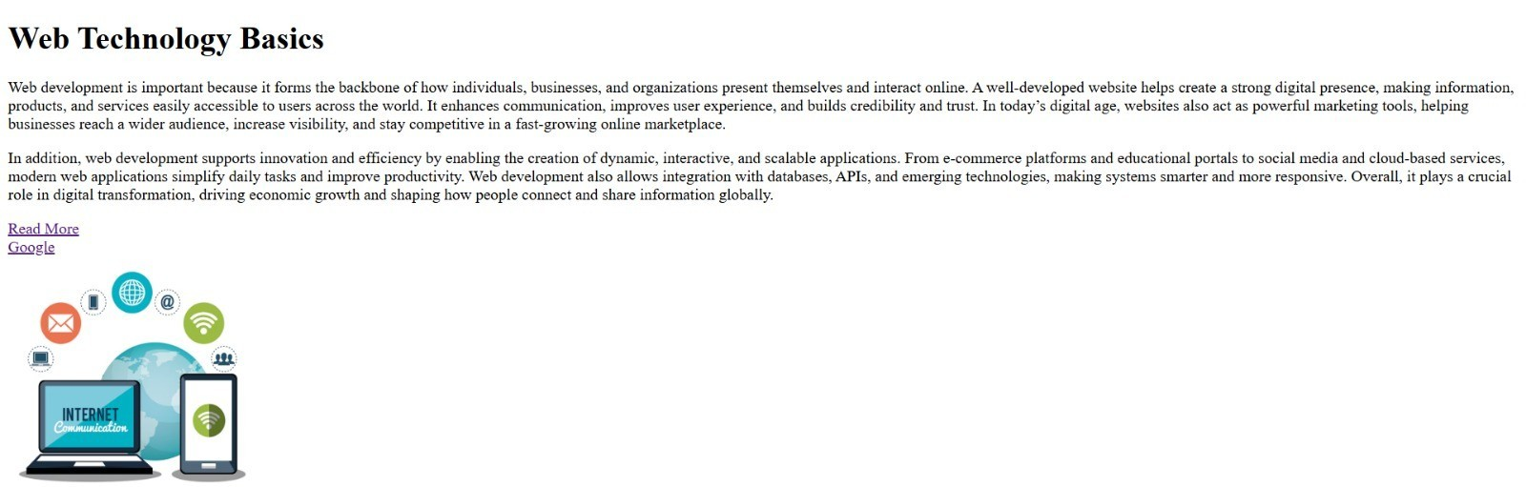

Q2. Write HTML code to generate the Lists
o Create an unordered list of at least five web browsers.
o Create an ordered list of at least five popular programming languages.
o Create a nested list showing Frontend Technologies (HTML, CSS, JavaScript) and Backend Technologies (Java, Python, PHP).
Code:
<html>
<title>My Lists</title>

<body>
<h1><b>html Lists</b></h1>
<h3><u>Unordered list of five Web Browsers</u></h3>
<ul>
<li>1. Google Chrome</li>
<li>2. Microsoft Edge</li>
<li>3. Mozila FireFox</li>
<li>4. Safari Browser</li>
<li>5. Brave</li>
</ul>

<h3><u>Ordered list of five popular Programming Languages</u></h3>
<ol>
<li>Java</li>
<li>C</li>
<li>C++</li>
<li>Python</li>
<li>html</li>
</ol>

<h3><u>Nested List Showing Different Technologies</u></h3>
<ul>
<li>Frontend Technologies</li>
<ol>
<li>HTML</li>
<li>CSS</li>
<li>JavaScript</li>
</ol>
<li>Backend Technologies</li>
<ol>
<li>Java</li>
<li>Python</li>
<li>PHP</li>
</ol>
</ul>
</body>
</html>
Output:
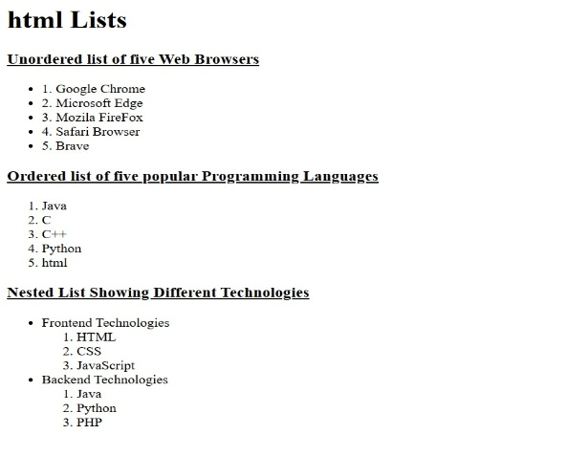

Q3. Write an HTML snippet to display the following text using proper formatting tags:
o Display the sentence "Internet and Web Technology" in bold.
o Display the word "HTML" in italic.
o Display the phrase "Core Concepts" with an underline.
o Write the formula for the square of a binomial:
(A + B)² = A² + 2AB + B²
o Write the chemical formula for water as: H₂O
Code:
<html>
<body>
<p><b>Internet and Web Technology</b></p>
<p><i>HTML</i></p>
<p><u>Core Concepts</u></p>
<p>(A + B)<sup>2</sup> = A<sup>2</sup> + B<sup>2</sup> + 2AB</p>
<p>H<sub>2</sub>O</p>
</body>
</html>
Output:

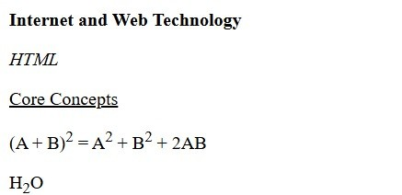

Q4. Create a navigation menu at the top with 3 links: Basic Tags, Lists, and Formatting Tags. On clicking each link, the page should scroll to the respective section (use bookmarks/anchors).
Code:
<!DOCTYPE html>
<html>
<head>
<title>Navigation Menu</title>
<style>
nav {
padding: 10px;
}
nav a {
color: black;
margin: 15px;
text-decoration: none;
font-weight: bold;
}
nav a:hover {
text-decoration: underline;
}
section {
display: none;
padding: 20px;
}
section:target {
display: block;
}
</style>
</head>

<body>

<nav>
<a href="#basic">Basic Tags</a>
<a href="#lists">Lists</a>
<a href="#formatting">Formatting Tags</a>
</nav>

<section id="basic">
<h2><u>Basic Tags</u></h2>
<p>These are the Examples of html Basic Tags: <br>
<li>HTML : &lt;html&gt;</li>
<li>Body : &lt;body&gt;</li>
<li>Head : &lt;head&gt;</li>
<li>Paragraph : &lt;p&gt;</li>
<li>Title : &lt;title&gt;</li>
<li>Heading Tags : &lt;h1&gt; to &lt;h6&gt;</li>
</section>

<section id="lists">
<h2><u>Lists</u></h2>
<p>There are Ordered List and Unordered List in HTML.</p>
<p>
<h3>Unordered Lists</h3>
<ul>
<li>Java</li>
<li>Python</li>
<li>C</li>
</ul>
<h3>Ordered Lists</h3>
<ol>
<li>Java</li>
<li>Python</li>
<li>C</li>
</ol>
</p>
</section>

<section id="formatting">
<h2><u>Formatting Tags</u></h2>
<p>There are different Formatting Tags in HTML: <br> <b>BOLD</b> <br> <i>Italic</i> <br> <u>Underline</u> <br> <strong>Strong</strong> <br> <em>Emphasis</em> <br> <marquee>Marquee</marquee>
</p>
</section>
</body>
</html>
Output:
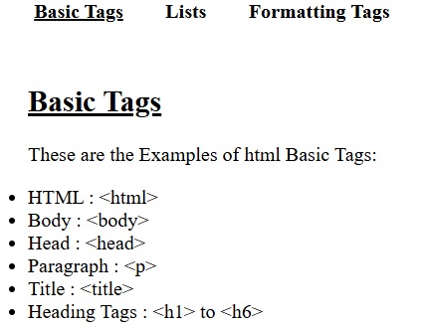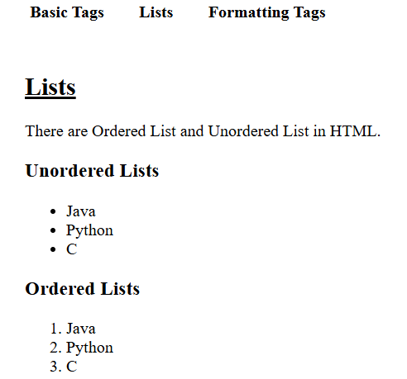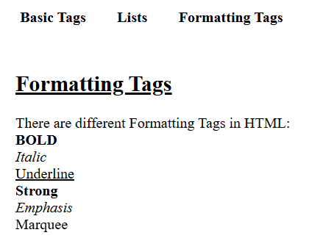
Q5. Download icons of LinkedIn and GitHub and add them to your page in such a way that once you click on them, they will take you to your respective profiles.
Code:
<html>
<body>
<a href="https://www.linkedin.com/in/ronit-kumar-swain-3b94a3303/" target="_blank"><img src="linkedin.png" width="250" height="250"></a>
<a href="https://github.com/Ronit-kumar-swain-07" target="_blank"><img src="github.png" width="400" height="200"></a>
</body>
</html>
Output:
